**LAB 8 GIT LINK:-** <https://github.com/Dulsha-amilan/Lab-8_DL_IT21357930.git>

**Reinforcement Learning**

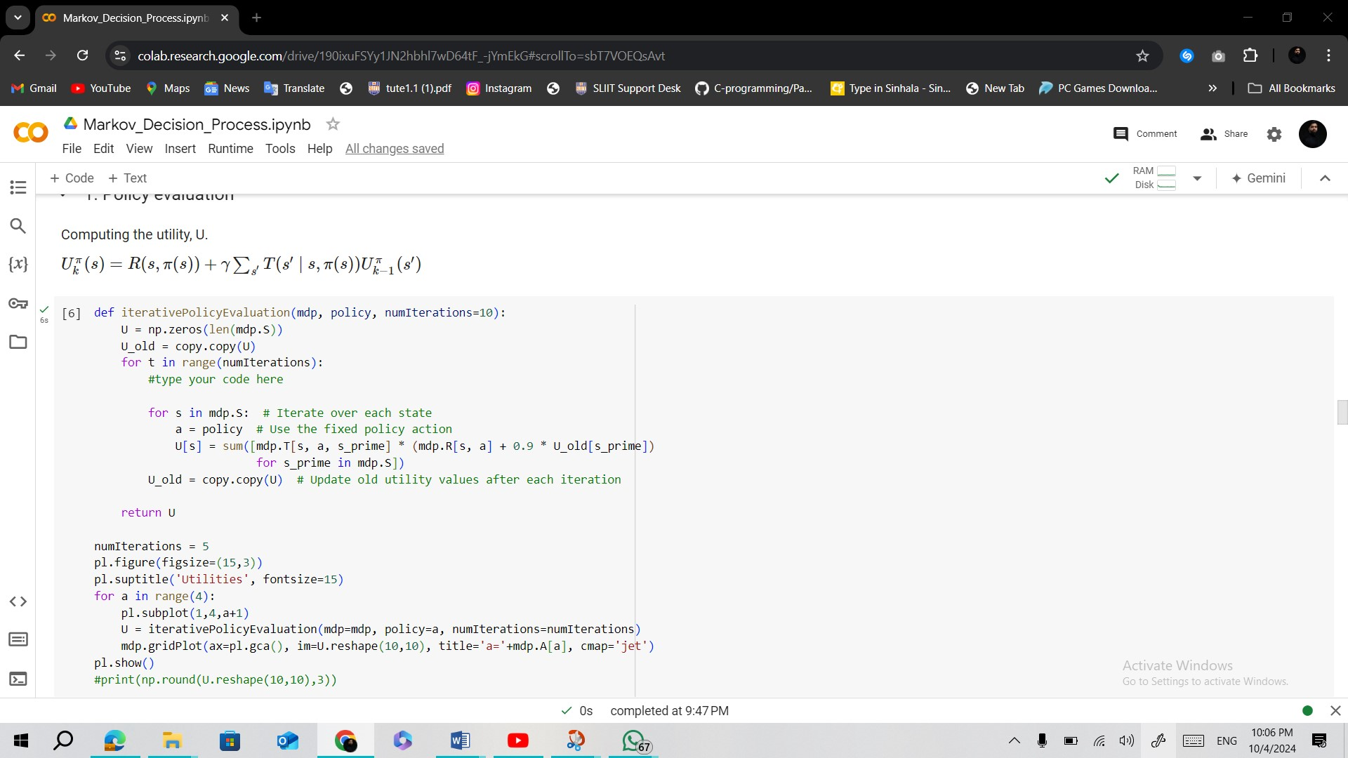

**Markov_Decision_Process.ipynb screen shots  
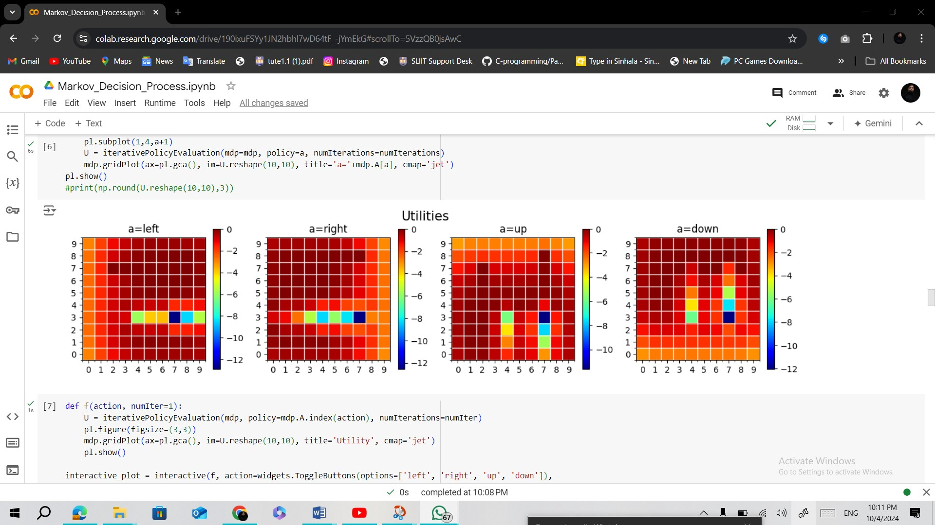  
  
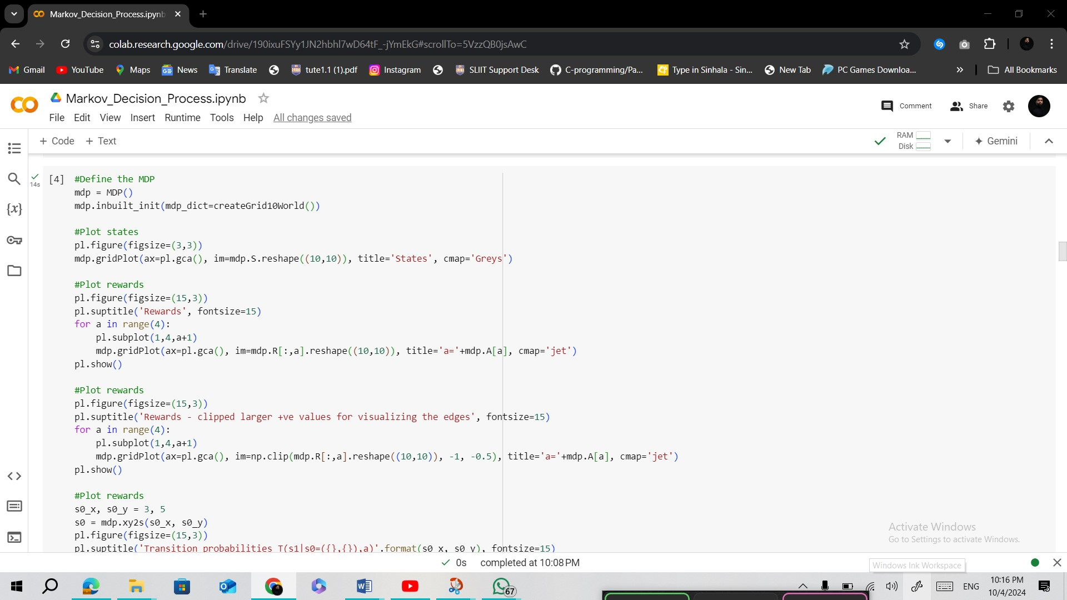  
  
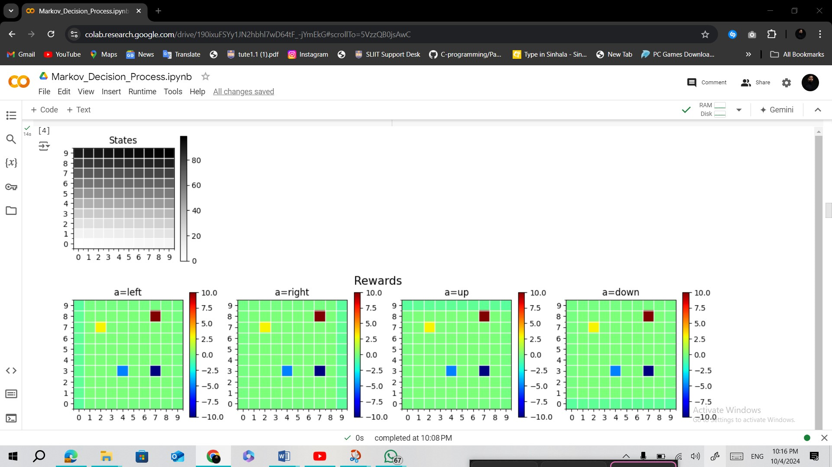  
  
  
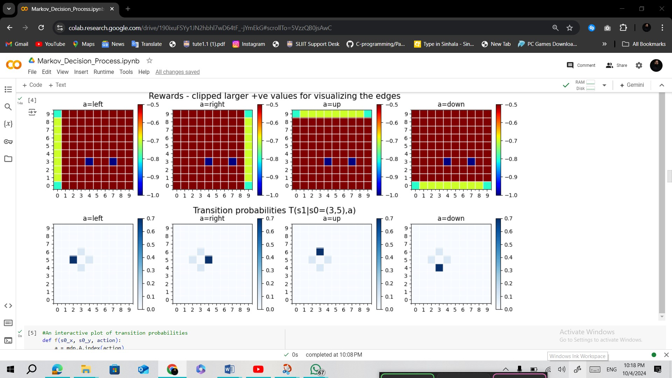  
  
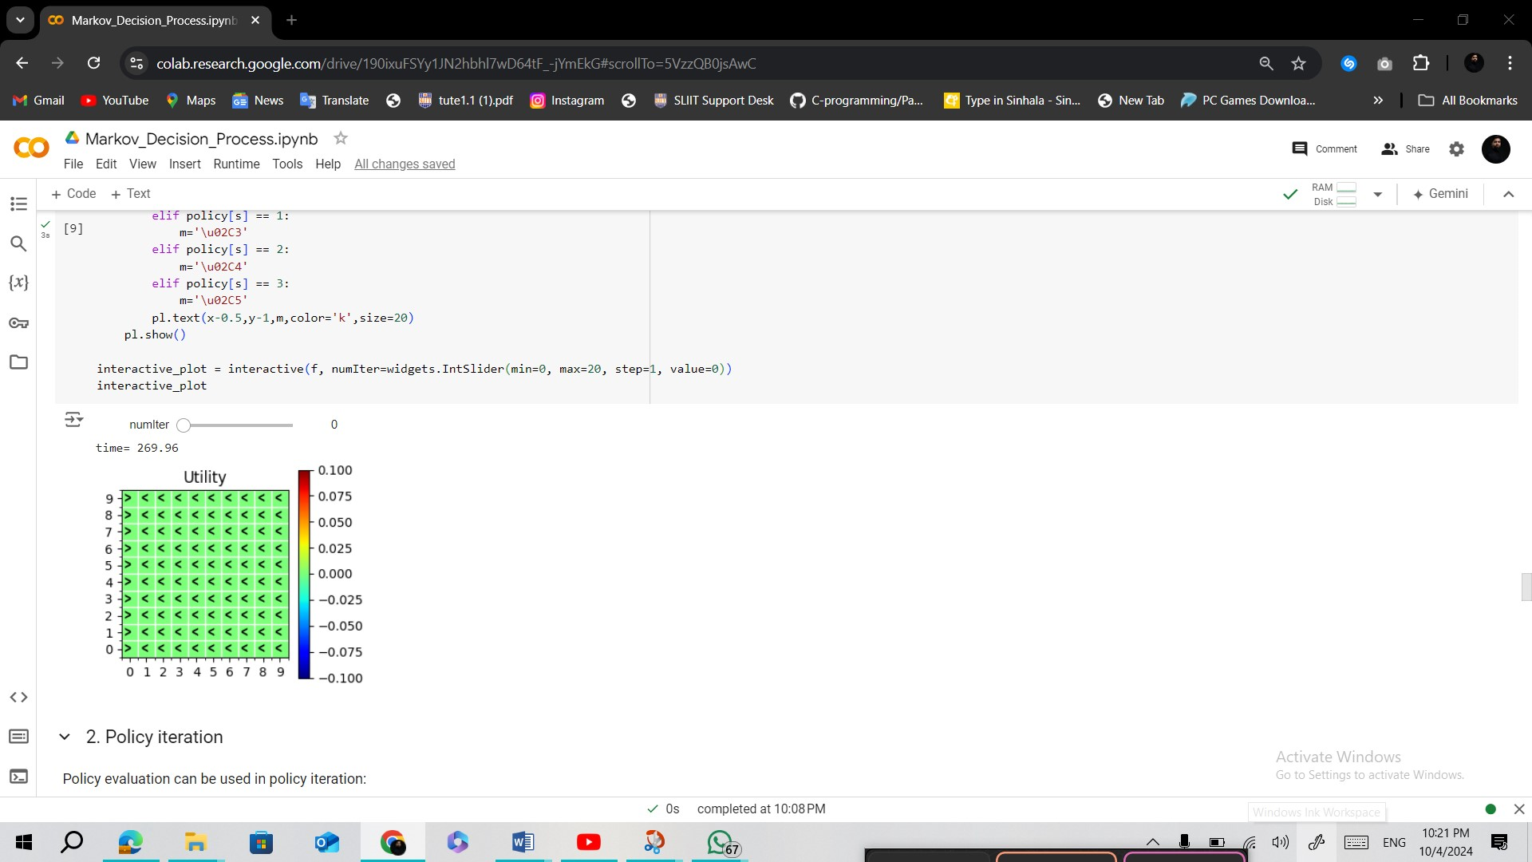  
  
  
  
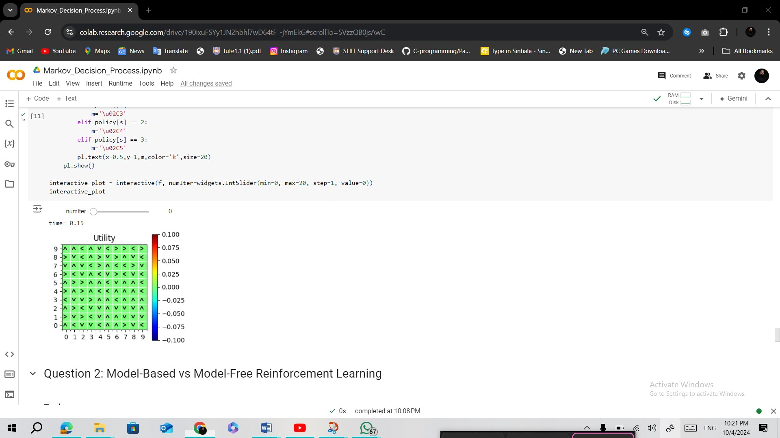  
  
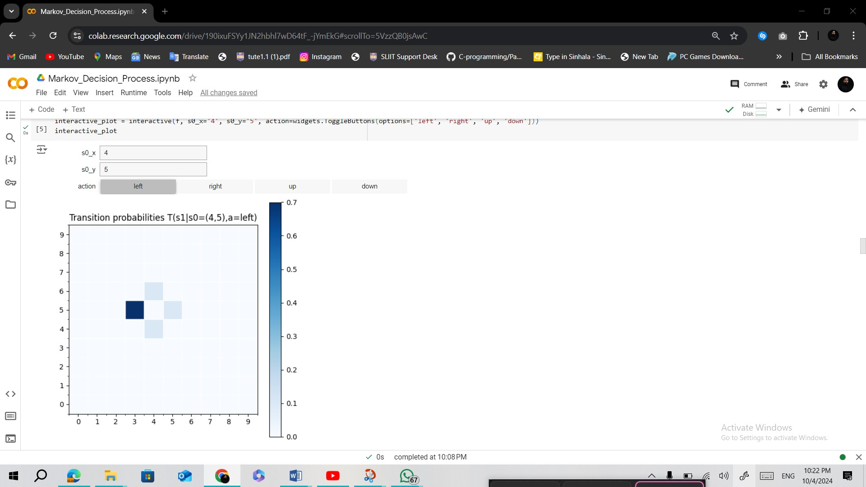**

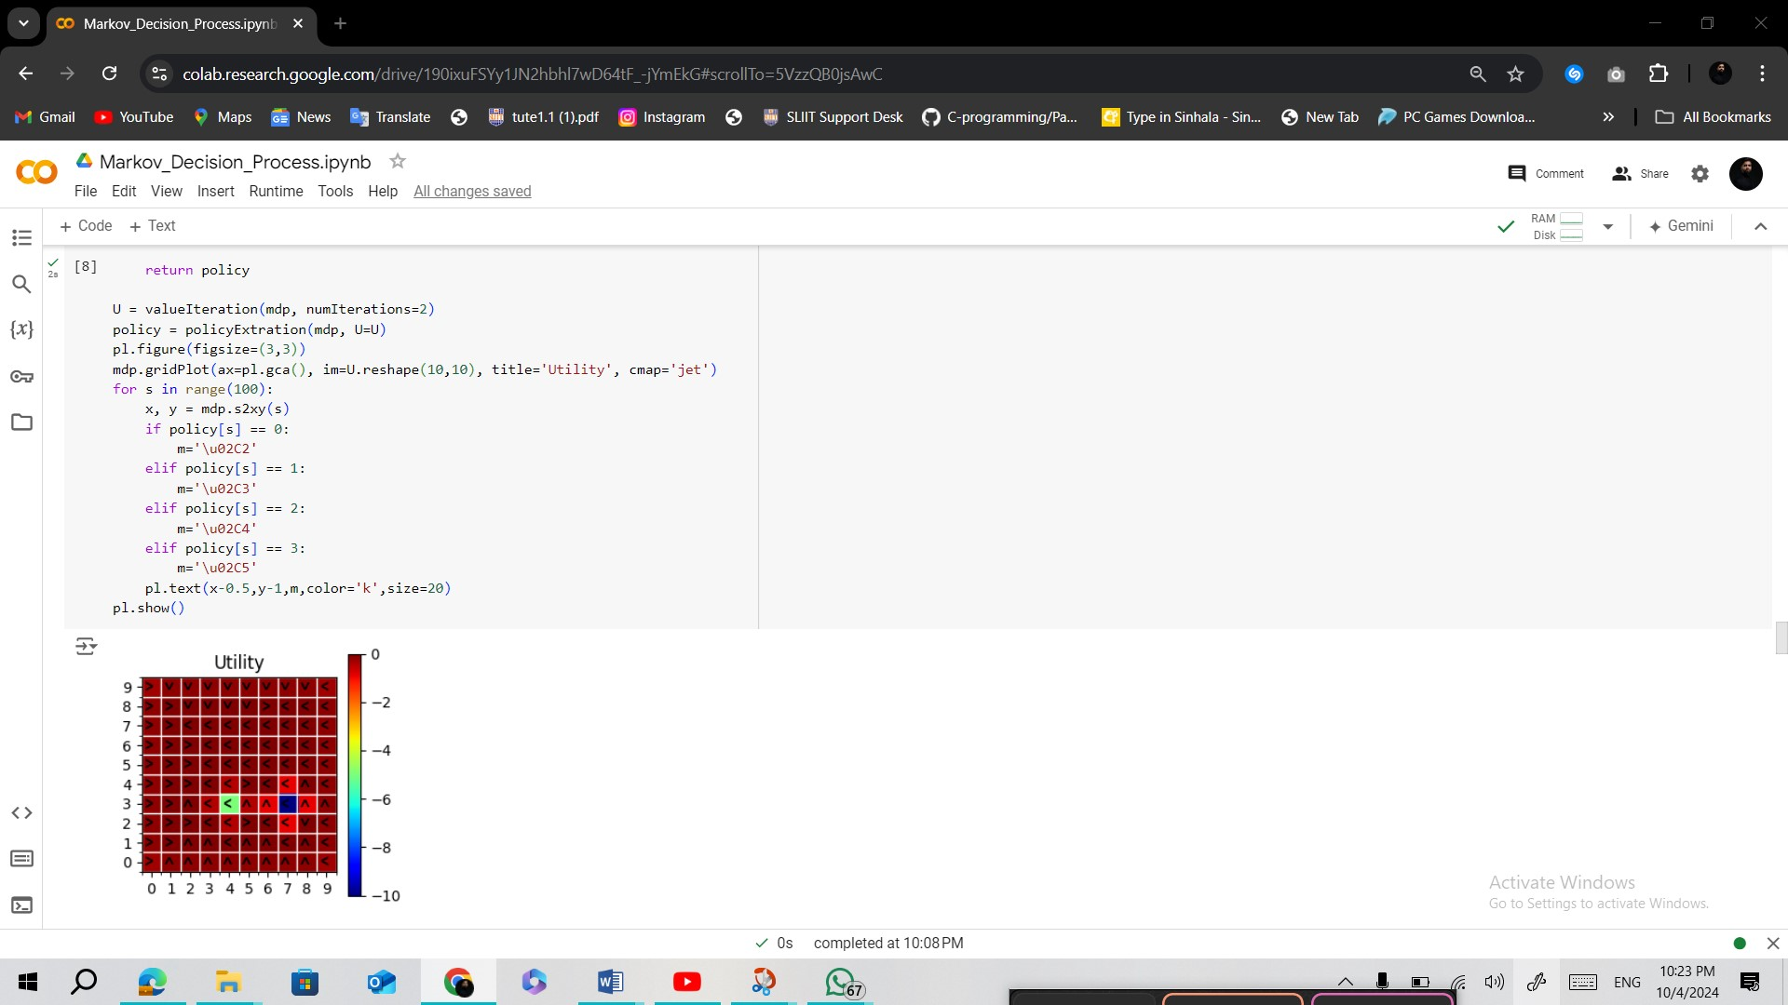

**Gridworld.ipynb  
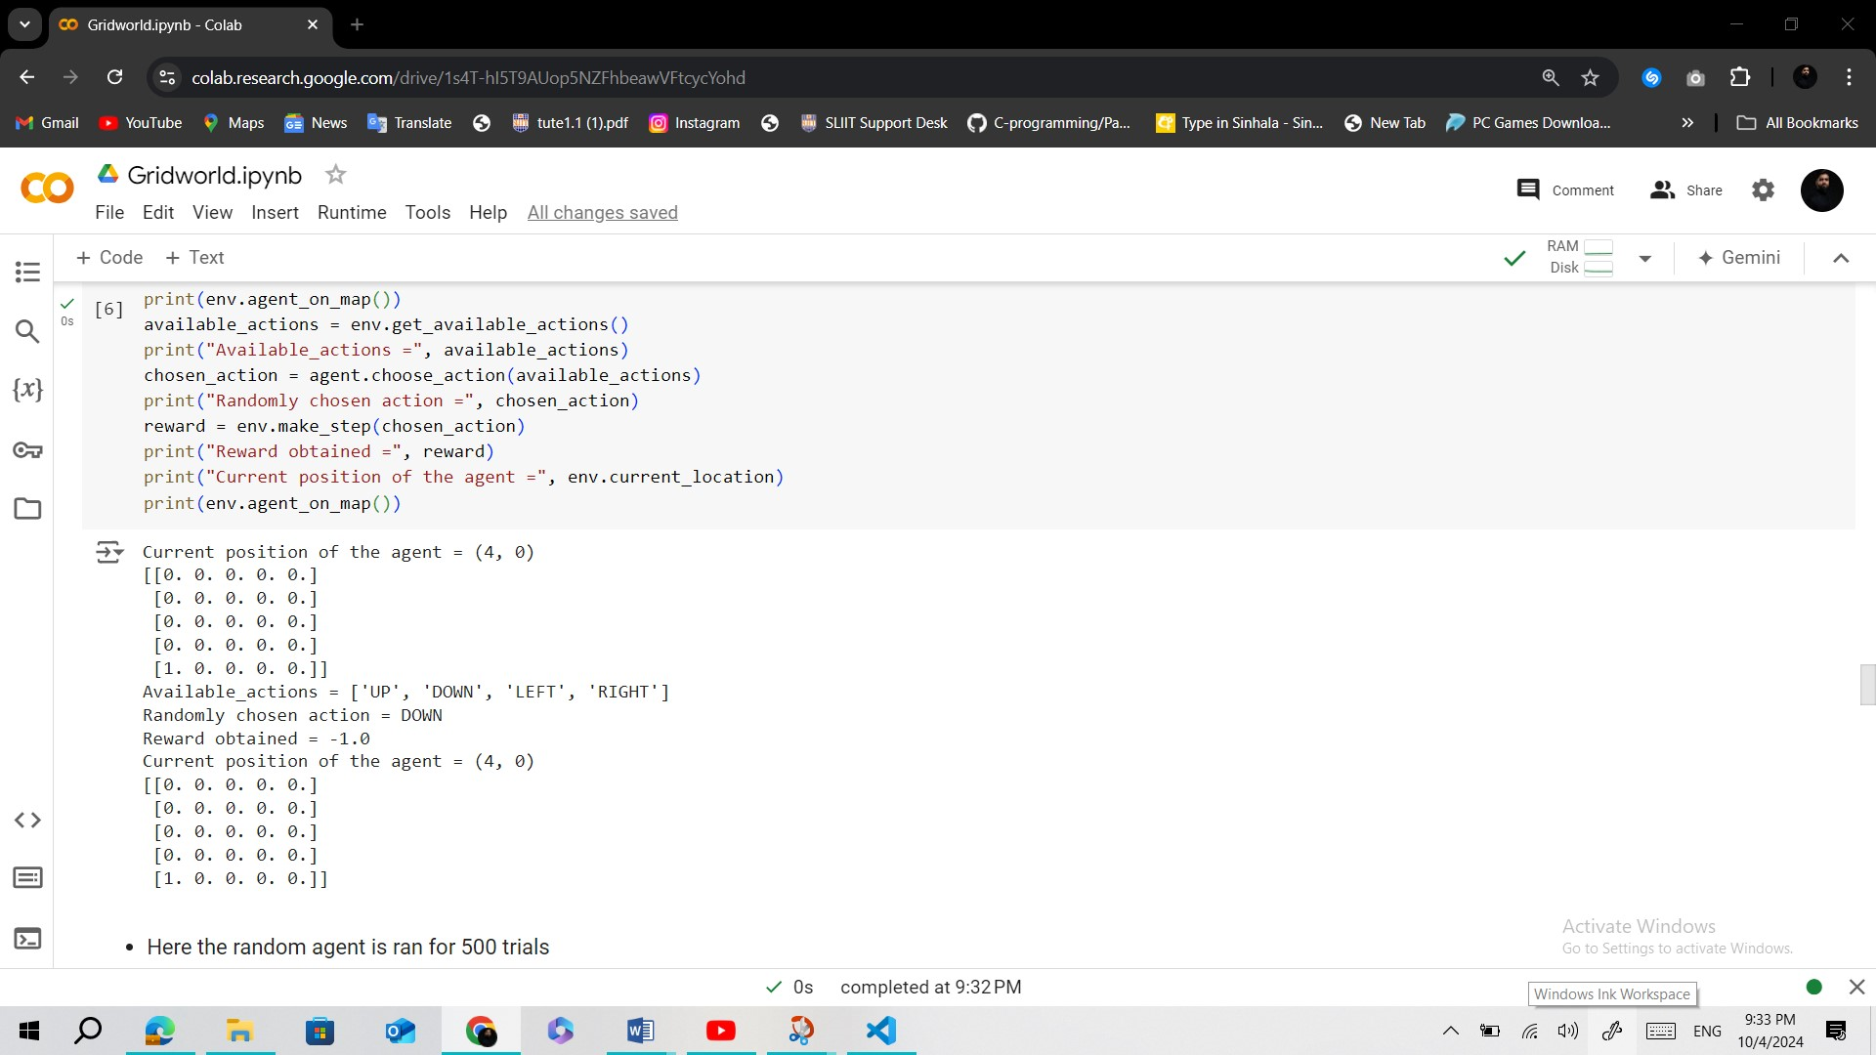  
  
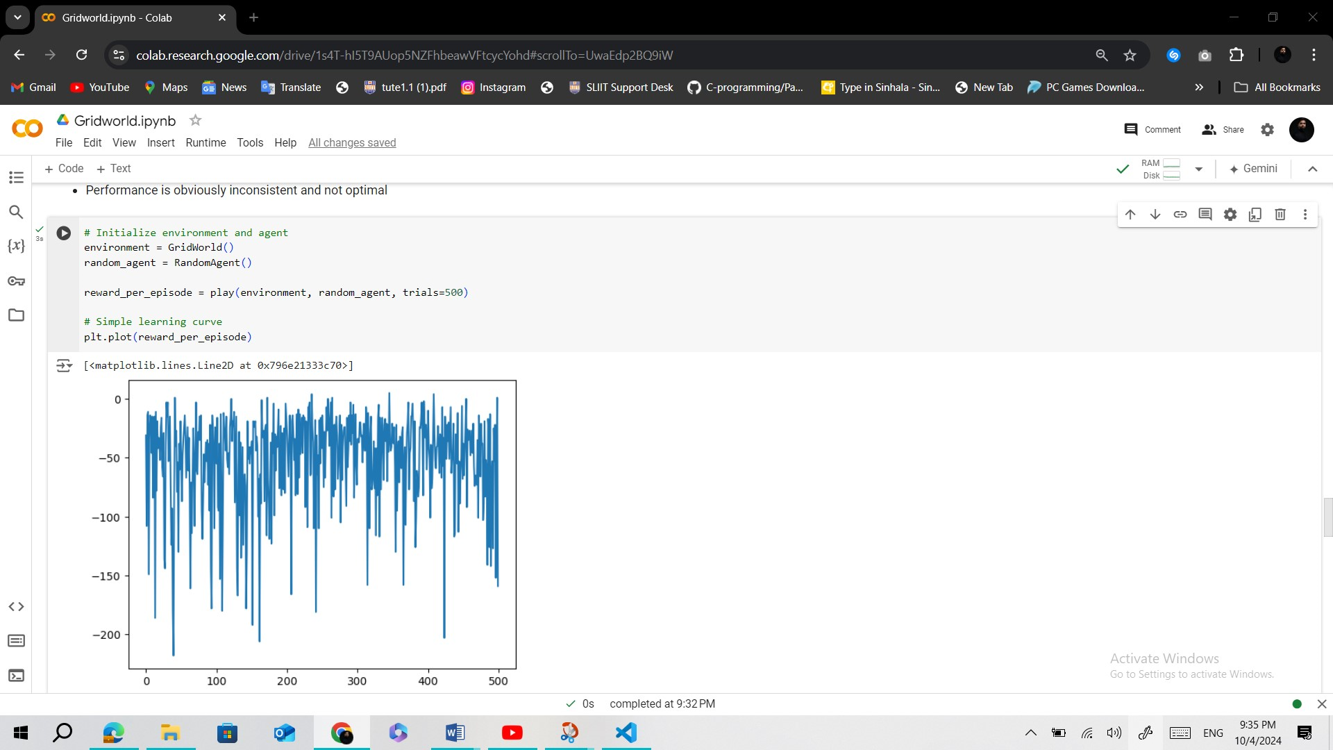  
  
  
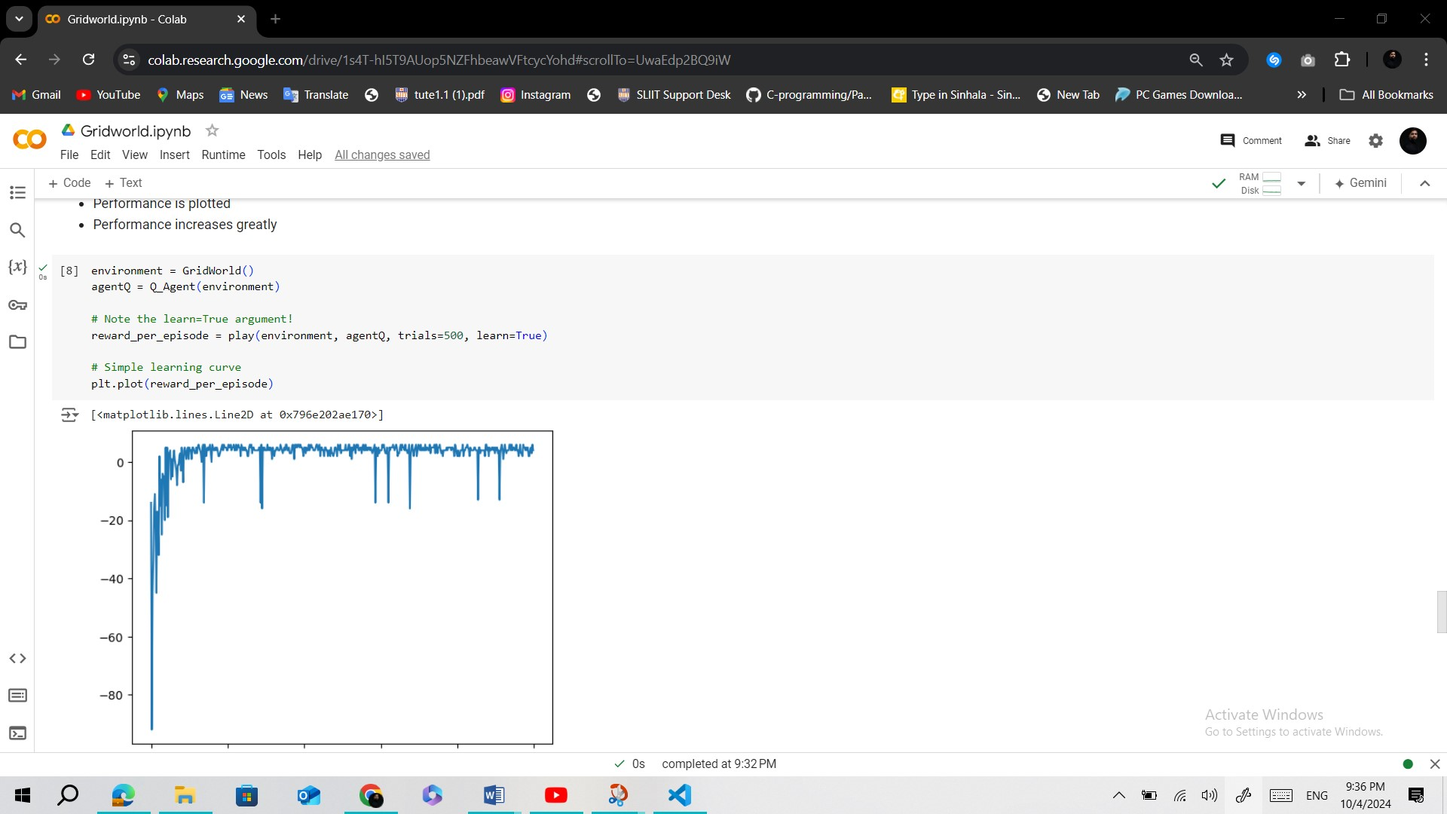**

**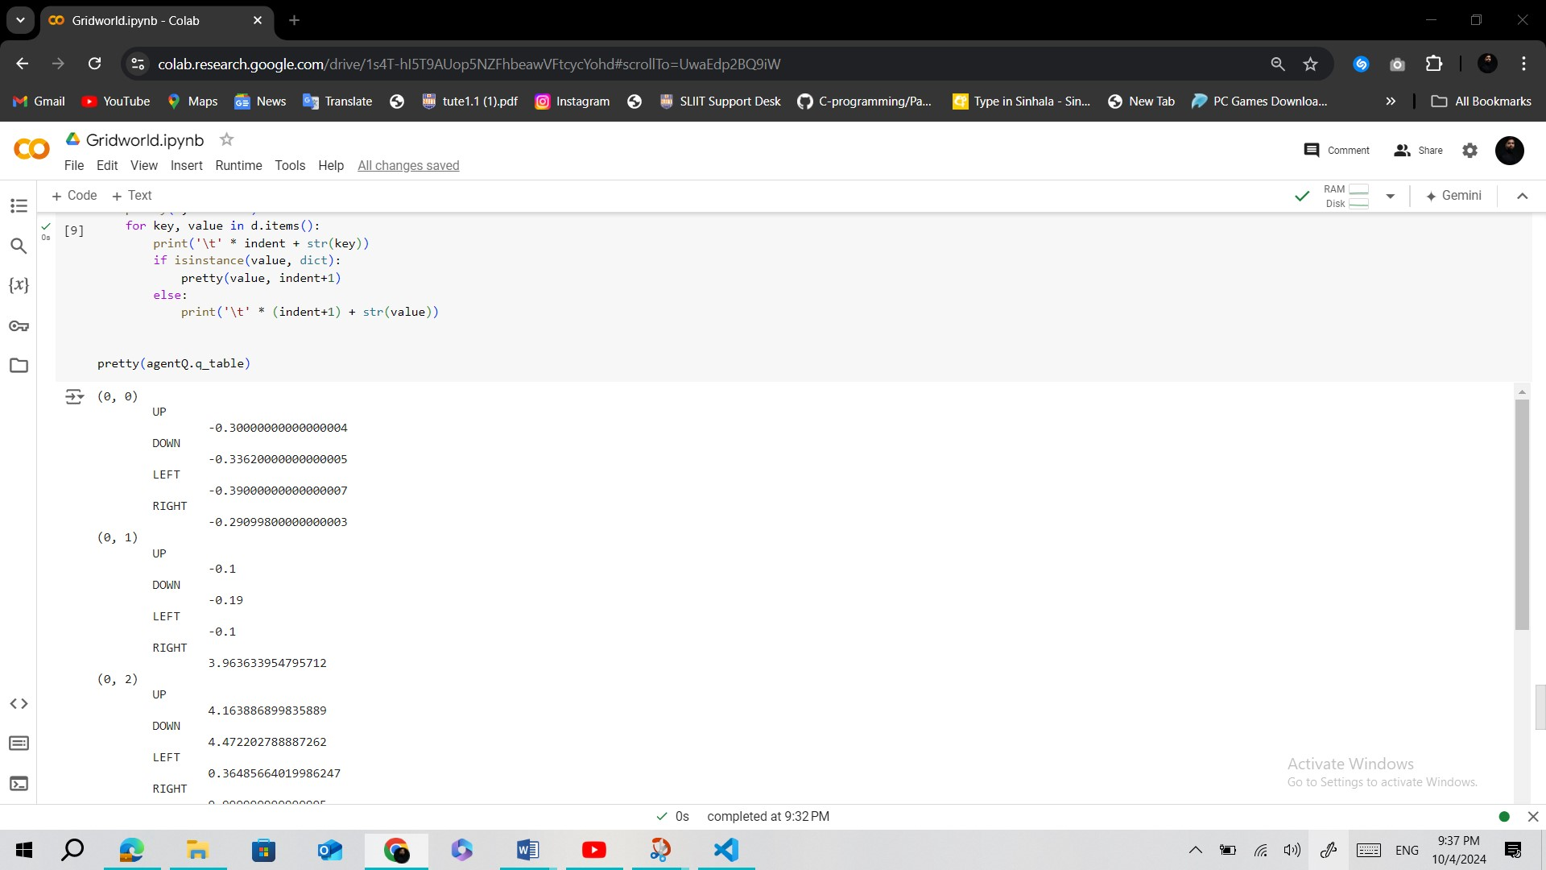  
  
  
Question 2: Model-Based vs Model-Free Reinforcement Learning**

**2.**

**Model-Based Algorithms**

**Learns a model of the environment, utilizing planning to optimize decisions.**

**Definition**: These algorithms explicitly construct a model of the environment, encompassing its dynamics, including state transitions and rewards.

**How They Work**: They use this model to simulate future states and evaluate the outcomes of actions, allowing the agent to plan its actions based on predicted results.

**Examples**: Value Iteration, Policy Iteration, Dyna-Q.

**Advantages**:

- They can be more sample-efficient since they leverage the model to simulate experiences.

- They are suitable for environments where the dynamics are known or can be effectively learned.

**Disadvantages**:

- Building an accurate model can be computationally expensive and complex, especially in large or continuous spaces.

**Model-Free Algorithms**

## Learns policies directly from experience, relying on trial and error without a model.

These algorithms, unlike others, don’t construct or utilize a model of the environment. Instead, they directly learn from interactions with it.

**Here’s how they work**: They rely on a combination of exploration and exploitation to update the value of states or actions based on the received rewards, without simulating future states.

**Examples include** Q-Learning, SARSA, and REINFORCE.

**Advantages**:

- These algorithms are simpler and often easier to implement since they don’t require a model.

- They’re effective in environments where the dynamics are unknown or too complex to model.

**Disadvantages**:

- However, they’re typically less sample-efficient, as they may require many more interactions with the environment to learn optimal policies.

**Question 3: Introduction to Deep Q-Learning (DQN)  
